Professor Ordinarius (full professor) Dr hab. Barbara Lewandowska-Tomaszczyk

barbara.lewandowska.tomaszczyk@gmail.com
blt@konin.edu.pl

State University of Applied Sciences
Head of Department of Research into Language, Literature and Translation

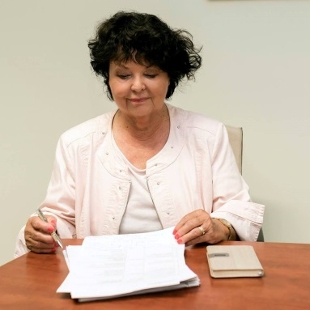
Fields of research: English and contrastive linguistics, cognitive semantics, corpus linguistics, cultural linguistics, lexicography, translation studies, discourse analysis

Barbara Lewandowska-Tomaszczyk (PhD 1972, Dr habil. 1987 Conceptual analysis, linguistic meaning, and verbal interaction – Polish Ministry of Education Award) is professor ordinarius of English language and linguistics at the State University of Applied Sciences in Konin and head of Department of Research in Language, Literature and Translation, for many years at the University of Lodz, where she held the position of professor and Chair of English Language and Applied Linguistics. She is also active at the Linguistic Committee of the Polish Academy of Sciences, prof. Lewandowska-Tomaszczyk was honorary professor in Linguistics and Modern English Language at the University of Lancaster, UK. Her research interests are primarily in cognitive cultural semantics and pragmatics of natural language, corpus linguistics and their applications in translation studies and FL pedagogy. She has published books and over three hundred papers in those areas and organized numerous international conferences and seminars. Over the years prof. B. Lewandowska-Tomaszczyk has been invited to read papers at international conferences and to lecture and conduct seminars at European, American and Asia universities. She served as President of the Polish Cognitive Linguistics Association for two terms (2002-2007) and has coordinated numerous international programmes and was involved as the PELCRA team leader in a number of large EU and national projects (FP6 IntUne, COST A31, and the National Corpus of Polish). Prof. Lewandowska-Tomaszczyk supervised and refereed a number of dr habil, doctoral and MA dissertations and is Chair of the Advisory Board of the Summer Institute of Languages in Contact/in Contrast (SILCC). She is member of editorial boards and Editor-in-Chief of the series Lodz Studies in Language with Peter Lang (Frankfurt a. Main). She’s been active at the International Communication Association - organized a large international congress in 2015 in Lodz - and cycles of workshops and conferences in Konin, inter alia panels on Competences of Contemporary Translators and biannual meetings devoted to the theme of Contacts & Contrasts in Language Literature, and Culture. Two volumes of the latest meeting have just been published in Springer and the next conference in the cycle - on Cultural Conceptualizations in Language, Literature, and Translation – was held in April, 2019.

