1. R₁ =R₂ =R₃ =R₄ = R₅ =8kΩ  R_{AB} =10kΩ | 3p.
1. R1 =R2 =R3 =R4 = 400 Ω  RAB= 100 Ω | 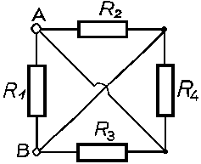

1. R₁ =R₂ =R₃ = R₄ =R₅ = R₆ =R₇ = 13 Ω
R_{AB} = 21 Ω

1. R₁ =R₂ =R₃ = R₄ = R₅ = 90 Ω  R_{AB}= 45 Ω | 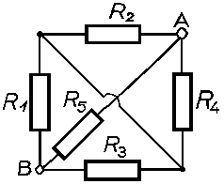
1. R₁ =R₂ =R₃ =R₄ = 8 kΩ  R_{AB}= 8 kΩ | 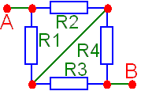
1. R₁ =R₂ =R₃ =R₄ = 12 Ω  R_{AB} = 9Ω | 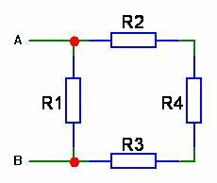
1. R₁ =R₂ =R₃ =R₄ = 20 Ω

R_{AB}=5Ω
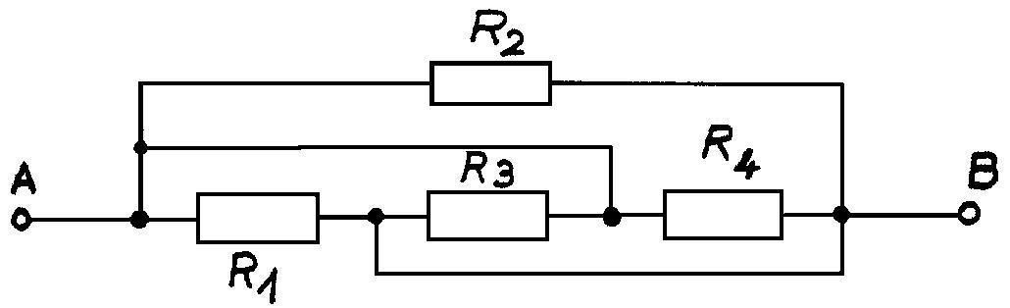
1. R₁=R₂=R₃=R₄=R₅=R₆=R₇ =650Ω

R_{AC}=300 Ω

