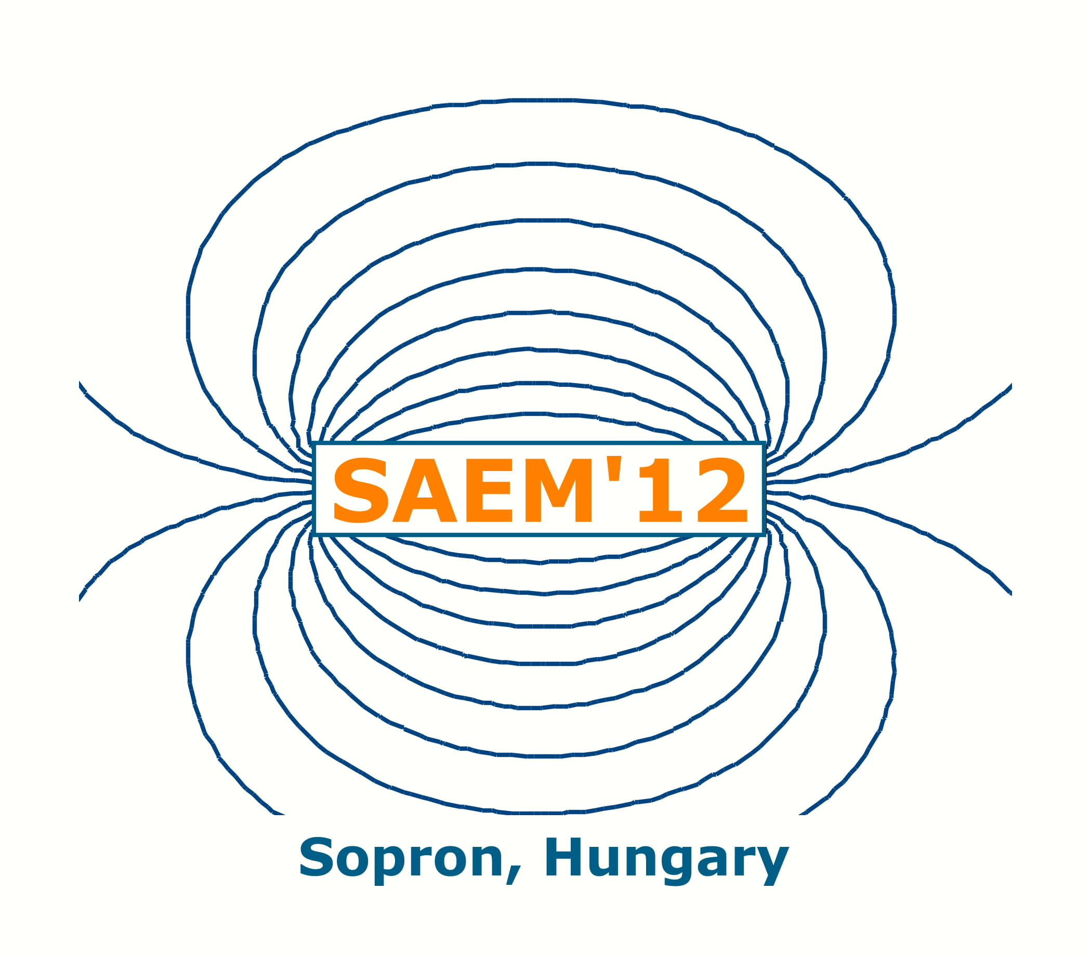 | INVESTIGATION SOME ELECTROMAGNETIC CHARACTERISTIC OF PM SYNCHRONOUS MOTOR IN FLUX WEAKENING OPERATION

Istvan Szenasy

¹Széchenyi István University, Faculty of Engineering Sciences,
Department of Automation
Egyetem tér 1, H-9026 Győr, Hungary, e-mail: szenasy@sze.hu

Introduction

Field weakening is required in order to limit the induced voltage above the nominal velocity for a PM synchronous motor also. In the case of applying permanent magnets their flux must be reduced using some applicable solution. Turning the current vector forward and further increasing in torque angle reduces the effect of the main flux. On turning the current vector ahead, this act with a constant current begins to decrease the flux. Increasing velocities and breaking it requires varying adjustment the torque angle.
We had developed a 100 kW power PMSM by Infolytica program and made simulations for investigate some characteristics on the flux-weakening region as power factor, the loss of stator teeth hysteresis and the loss of stator teeth eddy current.

Extending velocity range, field weakening

As it is known, considerably above the nominal velocity for a PM synchronous motor field weakening is required in order to limit the voltage. The flux of the magnetic field generated by the permanent magnets does not change by itself in PM synchronous motors.
Up to reaching the nominal velocity the terminal voltage must be increased in proportion to the frequency i.e., in proportion to the speed if the supply is intended to be performed by unchanged current. Without further increase in the terminal voltage, the motor cannot be used for an increase in velocity, only with a considerably decreased torque.
Fig 1 shows the changes in the power and the voltage in function of ω.

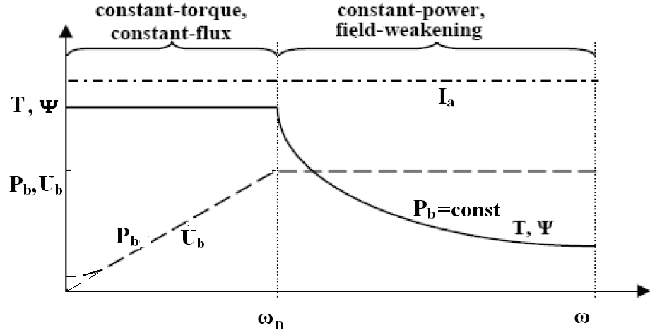

Fig 1. Torque, power and voltage vs. speed normal and flux-weakening region.
In the case of speed nominal, the values of the flux and the torque are constant just as in asynchronous motors. In a range above this, only the power can remain constant applying a supply with constant voltage. On the other hand, the flux and the torque decrease in a hyperbolic way, if this intention can be realised.
For a possible use in a little city bus and supplied from battery, we had developed a surface mounted and outer rotor type PMSM motor by Infolytica program system. The type of winding is fractioned rated of slots and pole for achieving a plane torque development.
In its imagined application the maximum speed is 2500/min.The back emf is 460 V_{peak} at 1000/min therefore above this speed the flux weakening is indispensable. The main characteristics are shown in Fig 2.

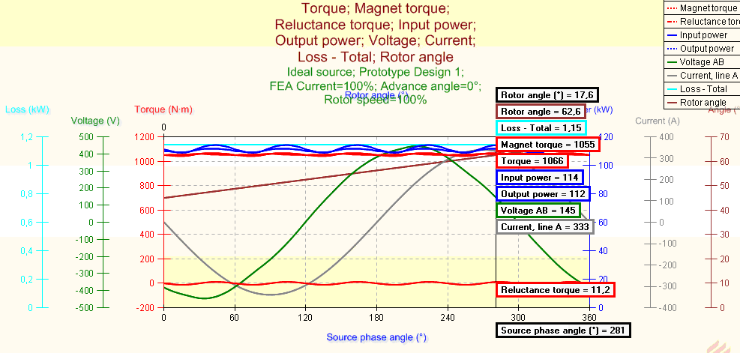

Fig 2. The main characteristics in nominal state by zero advance angle.

For realize this results we suppose a motor control with available flux-weakening operation. We have done several simulations by Infolytica for investigate some main characteristics of this PMSM in this expanded region namely the power factor, the loss of stator teeth hysteresis and the loss of stator teeth eddy current. The functions of results are made by Matlab. Fig 3 shows the loss of stator teeth hysteresis vs. advance angle.

Fig 3. The loss of stator teeth hysteresis vs. advance angle

The full paper deal with these results and with some aspect for its realisation.

References
[1] Szenasy I., Some developing and controlling problems of PMSM motors applied for modern drives for EV-s. Presentation in Conference to Drive for Road Vehicle, by MTA, Budapest, 2012 01 23.
[2] Krishnan, R. PMSM and Brushless DC Motor Drives. CRC Press 2010. ISBN 978-0-8247-5384—9.

